

Birdie Level
Golf Instruction Tips and Drills

Grip, Stance and Posture Basics

Before splitting into groups for the activities go over the basic grip, stance and posture fundamentals. Work individually with each child to get a good starting position. See diagrams below.

Hold Cues:
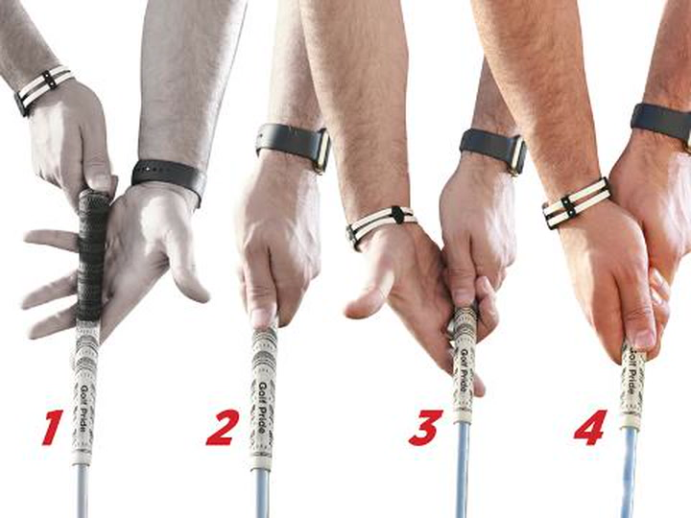

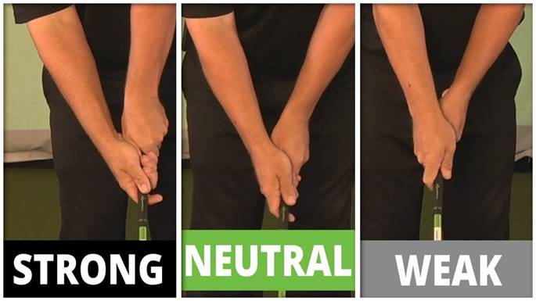
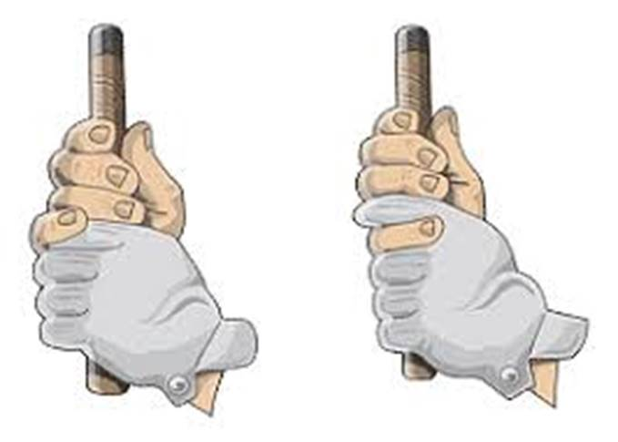

Set Up Cues:
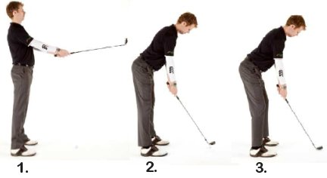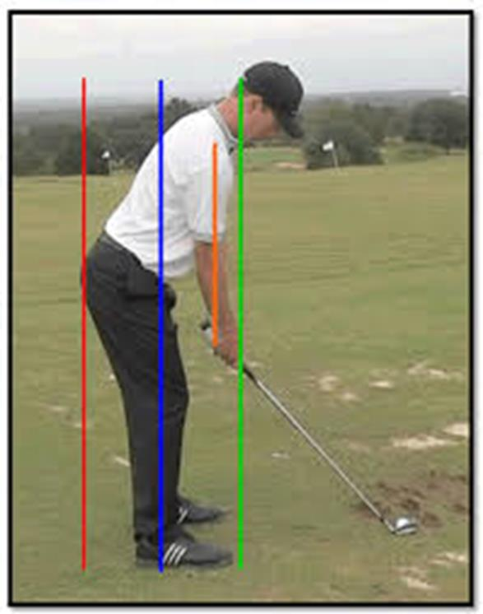

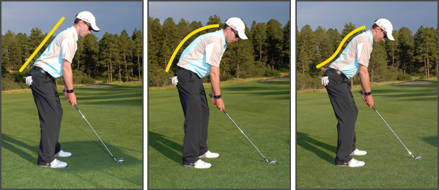
Yes No No
Alignment Cues:
Golf Swing Aim and Alignment
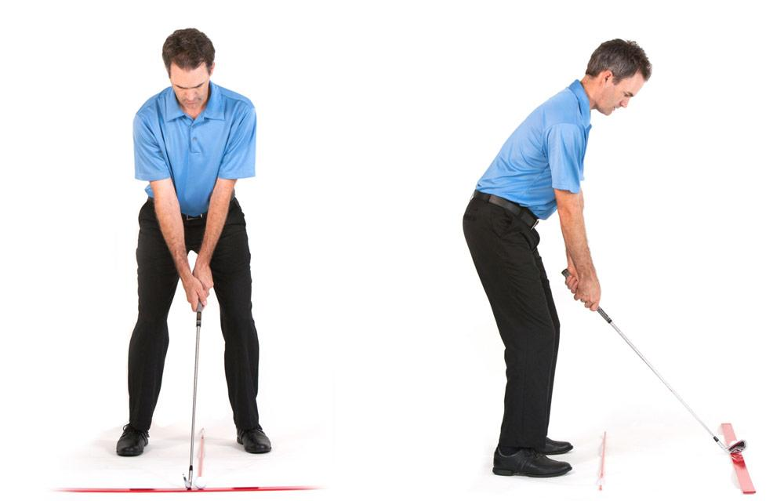
Alignment is the concept of addressing the golf ball with your body and club face directed precisely at the intended target. If consistent results are expected, then a consistent alignment is necessary. Otherwise, if a player’s alignment changes for every golf shot, every golf swing must change in order to produce consistent results.
Determine a Target and Target Line
Once all other variables have been considered (wind, slope, hazards, lie, etc.), you must decide on a distinct point where you intend the ball to finish. Let’s assume a straight ball flight is desired; working the ball will come later. The target cannot be a generalized area, but should be as precise as possible. Consider a straight line from the ball to the target to be the target line. This will be the focus around which all alignment takes place.
Soling the Clubhead
Begin with the clubhead. Clubface angle is one of only 2 major variables that determine the direction the golf ball will travel, so be precise. Be sure that the sole, or bottom of the clubhead rests completely flat on the ground. Neither the toe nor heel of the club should be raised higher than the other. In other words, the grooves on the clubface should be parallel to the ground. This will affect direction as well as consistency of contact.
Clubface Alignment
Be sure that the leading edge, bottom edge, and/or grooves of the clubface are set perpendicular to the target line. Depending on the club being used, a few degrees off with clubface alignment could mean many yards off line for the shot. When the club is set in the proper position, trust it, and leave it alone for the remainder of the setup.

Body Alignment
Assuming you are hitting a straight shot, your body will be facing exactly perpendicular to the target line. An easier way to regard this problem is to look at line drawn across a player’s feet, knees, hips, shoulders, and even eyes. Ideally, all of these connecting lines should align parallel to the target line. This is one of the most important, but underrated aspects of the entire golf swing. Tour professionals check this alignment on a daily basis. Before you begin, notice that your body is aligning parallel to the target line and not at the target itself. Many players make the mistake of directing both the clubface and their bodies at the target. This would mean that the two lines are not parallel, but converging. For right-handed players, the body is aligned distinctly to the left of the target.
Using Golf Clubs or Tour Sticks for Alignment (Practice Only)
To be sure that your alignment is correct, you will need a few extra golf clubs on the practice range. First, place one club on the ground, in front of the golf ball, directed straight at your target. It may help to stand behind the ball to be sure that you are accurate. This will highlight your target line. Toe Line / Body Line Next, place another club on the ground just in front of where your toes will be at address. This club must be set perfectly parallel to the target line club (shafts should be equidistant from each other at both ends). Take a moment to step back behind the ball and notice where the second club is pointing relative to your target. As mentioned above, this shaft (for right-handed players) should align well to the left of the target. These are parallel, not converging lines.
Checking Body Position
When you are set up to the ball, hold still. Have someone hold a shaft across your heels, knees, hips, shoulders, and eyes while ensuring that all lines are parallel to both clubs on the ground. If one of these lines is significantly off-line, you will need to re-orient yourself and set up over again. When all of your lines are parallel, you will be aligned target-ward. This will give you the greatest chance of making a golf swing that is on plane, accurate, and consistent.
You might also note that because your right hand is positioned slightly further down the club than your left hand, your right shoulder may in fact be situated slightly lower than your left shoulder. This tilt in our shoulders is certainly okay and is actually expected. Alignment problems arise however, if we allow our shoulders to open, so be conscious of this tendency. Alignment calls for regular attention and maintenance as it directly affects the path that the club head will travel on, as well as how consistent your shots will reach your target.
In summary, the target line is defined as a straight line from the ball to our intended target. Start by setting the club face down on the ground first, trust it, and then let it serve as a guide for the rest of your set up. All of your body lines including your feet, knees, hips, and shoulders should be parallel to your target line. Because your right hand sits on the club lower than your left, your right shoulder may be situated slightly lower than your left. This is perfectly fine, just don’t allow your shoulders to open or close as this will affect the path that your club is going to travel.

Clubface and Ball Contact



At address, an open clubface is one where the line of the face of the club points to the right of the target line (for right handed golfers). This is contrast to a square clubface which faces directly straight ahead.

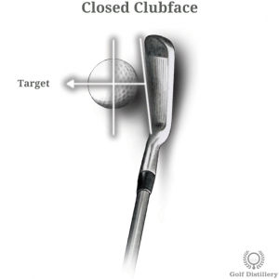

At address, a closed clubface is one where the line of the face of the club is pointing towards the left of the target line (for right handed golfers). This is in contrast to a square clubface which sees the club pointing directly at the target or an open clubface which sees it pointing to the right.
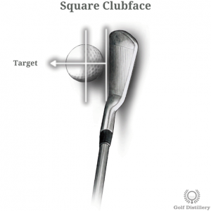

At address, a club placed on the ground in a square position is one where the line of the clubface is perpendicular to the target line. Indeed, a square clubface does not lean one way or the other and instead faces the target directly.

Improving your golf game begins by improving your ball striking, as there's nothing in golf quite like making pure contact. A pure golf shot is truly a magical feeling! Once you experience this sensation, you'll be hooked, trying to repeat it over and over again.

Achieving solid contact tends to be difficult for many golfers; it's what separates the pros and better players from average to higher-handicap golfers. The good news is that, if you experiment with the accompanying tips and drills, you too can learn how to hit solid and pure golf shots more often.

Golf tip: Hands forward upon impact
As you strike the golf ball, the grip end of the club needs to be leading the hands and club head through the hitting area (a mandatory ingredient for hitting solid iron shots). This move causes the club head to compress the ball into the ground, which helps make your divot after the ball, not before. (Many times you hear golf instructors say strike the ball first on iron shots - this is what they are talking about.)

Golf tip: Correct posture
The second key to achieving solid contact is having correct posture throughout the swing, as this allows you to swing the club on the proper plane. The majority of golfers who struggle with making solid contact lose their posture as the club head connects with the ball. This leads to many miss-hits; fat and thin shots, hooks, slices and chunks. It is essential that you keep your posture, just as it is at address, throughout the swing.

Golf tip: Control the clubface
The final ingredient in the search for solid ball striking is controlling the clubface through impact. In other words, the face of your club must be square when it contacts the ball. Most golfers have the face of the club too open at impact, which leads to miss-hits that cause loss of power and distance. The clubface should rotate from open (prior to impact) to square (at impact) to slightly closed (after impact). The timing of this face rotation is what separates good ball strikers from not-so-good ball strikers. Proper practice will improve this timing.
Golf ball drill: By placing an extra golf ball behind your ball (12 to 14 inches behind the target line), you will learn to strike the ball with a descending blow and have your hands leading the club head through the hitting area. If you use a scooping motion (hitting the ground before you make contact with the ball), you won't be able to strike your ball without first hitting the extra ball.

Body Balance - At the foundation of every good golf swing is good balance. Maintain your balance and you can deliver the club head to the ball with both speed and accuracy. Lose your balance and your swing loses its tempo, or rhythm, and falls apart.
To find the correct balance, it’s essential to know where your weight should be during the swing. Following are three balance checkpoints during the swing, as well as drills to help you feel the correct balance and more solid shots.

ADDRESS - At address, your weight should be balanced equally over the insteps of both feet — not toward the heels or the toes. This puts you in an athletic, ready position, like a tennis player awaiting serve. From this dynamic position, your body is ready to quickly move in any direction.
If your weight falls on your toes, the club head will tend to start outside the target line. If your weight rests on your heels, the path will tend to be too inside. Neither path is conducive to generating much clubhead speed or consistent contact.
To check your balance at address, simply jump straight up in the air. If you’re in balance, you should land comfortably on both feet without falling forward or backward.

TOP OF SWING - As your upper body coils, about 90 percent of your weight shifts over the right side. It’s imperative to maintain a good right knee flex. Many golfers lose their balance because of tension in their legs. They tighten their knees, which forces the right knee to straighten at the top of the backswing, leading to a reverse-pivot. At the top of the backswing, your balance point is over the middle of your right foot. If it is, you should be able to lift your left leg completely off the ground and hold the position to a count of three, without wavering.

FINISH - On the follow-through, the swing’s momentum should carry you to a full, balanced position, with almost all of your weight over your left foot. As your upper body unwinds, your shoulders should finish over your left leg, almost at a right angle to the leg. If your shoulders are leaning backwards at the finish, it’s very difficult to remain balanced. Your finish helps dictate your swing. Finish in balance and it’s a good bet your entire swing was in balance. If you’re stumbling at the finish, chances are your rhythm and timing are off, and the shot less than satisfying.

DANCE DRILL - To feel where your balance should be at the top of your swing and at the finish, try the following. From a position at the top of your backswing, lift your left foot off the ground, balancing your weight over your right leg. Then swing to the finish, lifting your right foot off the ground as your body rotates through the shot. Your weight should now be over your left leg. If you can do this drill without losing a step, you’re well on your way to a balanced swing.
NO PEEK DRILL - Find a safe spot on the driving range and take your normal swing, eyes open and focused on the target. Do not contact the ball. Then make the same swing blindfolded (or at least with your eyes closed). Finally, step up to the ball and try to hit it without looking.
Believe it or not, I’ve seen some great shots with the eyes closed. Why? Because when you’re unable to see the flight of the ball, it’s much easier to sense any disturbance in balance. You’ll know right away if you’re swinging the club too fast to control. When your vision is taken away, you begin to sense balance internally.

Try this drill several times, concentrating on maintaining balance. Once you become proficient hitting in the dark, try to maintain the same tempo with your eyes open.

Pick a Target
The first part of the aiming process is simply picking a target for the shot at hand.
Without a target in mind, the player will have no way of knowing where to aim, and will have very little chance of hitting a quality shot. The target doesn’t always have to be the hole itself, either.

No matter what kind of target they pick, it is absolutely essential that they do pick one before moving on to the next step.

Find an Intermediate Target
Find an intermediate target. This intermediate target is usually just a few feet in front of the ball, and it is located directly on the line between the ball and the selected target.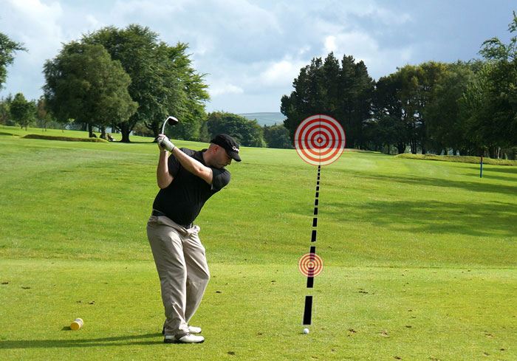
The idea is simple – instead of trying to aim at the target that may be hundreds of yards away, they can use the intermediate target that they have picked to aim their club properly. As long as they are aimed accurately with their intermediate target, they can feel great knowing that they are aiming correctly at the actual target as well.
So what should they pick for an intermediate target? They will be surprised at how many options they have when they look carefully at the ground in front of their ball. There is bound to be a small discolored spot or a blade of grass that is longer than the rest. Have them take a look down the target line while standing behind the ball and pick out something that they can easily spot from address. Once they stand over the ball, align their club face with that short target, take their stance, and get ready to hit a great shot.

- Target Selection- Picking out the target by looking down the target line-standing behind the golf ball and visualizing your shot, both ball and target.
- Distance to the Target- for beginning players this could be a simple as asking “do I use my far, medium or short distance club?” Intermediate players can identify the distance and make a club selection.
- Reaction to the Target- we want to encourage players to get ready (pick out a target), get set (set up to the ball), and go (swing wasting little time looking at the ball).

Think about this - If players pointed a camera at the ground (or the ball), the camera would take a different picture than if the players pointed a camera towards the target in the fairway. Some swing technique issues can be addressed by changing the lens through which the target is viewed.

A Key To Good Golf: Swing In Rhythm
Whether it's a drive off the first, a crucial putt at the last, or some other stroke in between, rhythm is an important ingredient to make a shot great—it's like the salt on french fries. Without it, the fries are OK. With it, your mouth waters before the first bite. Ever notice how a drive made with less effort produces a tee shot far better than if you take a rip at the ball? That's because you improved the rhythm of your swing. And though it might be a good idea to take your time when you hit driver, other shots require different rhythm. Take the greenside bunker shot you see me hitting here. This shot requires a little more energy. The buzzword I'm thinking about when I hit bunker shots is brisk. That gets me to swing through the sand a little amped up, so the club doesn't decelerate and leave the ball in the bunker. That's what I mean about swinging with good rhythm. If you want to improve your game from tee to green, scroll down for some other buzzwords to help improve your tempo on various shots.
– With Ron Kaspriske

DRIVER - BUZZWORD: PATIENCE
Grab a golf ball and toss it up, paying attention to the change of direction when it starts to fall back down. Notice how it seems to hover in mid-air for a moment before dropping. If you emulate this feeling of hovering when you change direction from backswing to downswing, you'll add good flow to your tee shots. Now for your buzzword. Before you take the driver back, think of the word patience. There's no rush to complete the backswing or to start swinging down. Look how my left heel has come off the ground like an old-school golfer's swing (below). You can use this as a cue to know when to change direction. Let it come off the ground as you swing back, and replant that heel before you start down. It will make your swing feel more in sync.

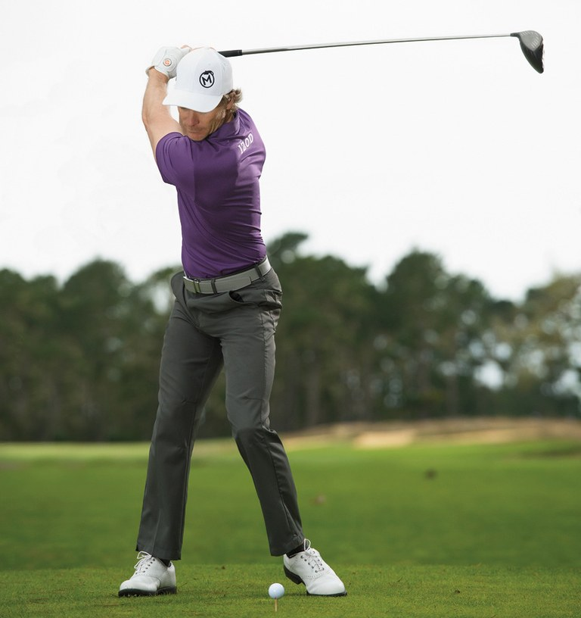

IRONS - BUZZWORD: SMOOTH
Whether it's nerves, adrenaline or the instinct to lift the club, a lot of golfers jerk their irons up and away from the ball as they start the backswing. This causes a lot of issues that have to be corrected on the way back down if you want to hit it solid and straight. Mostly, it's a rhythm killer. Like the patient transition at the top of a driver swing, you want to start your irons back with no appreciable effort. The buzzword here is smooth. The club should quietly trace the turf for a foot or two before you hinge it upward. A great drill to help you get the feel of this smooth takeaway is to address a ball with another ball behind your iron on the target line. Start the swing by rolling the second ball away (below). You can even use this image when you play—especially under pressure.



WEDGES - BUZZWORD: LIGHT
Shots inside 100 yards are often called finesse shots and require a different kind of rhythm.
A lot of it is determined before you take the club back. Like a shortstop getting ready to field a grounder or a point guard shooting free throws, you should feel nimble when you address these short-game shots. Soften your grip pressure, waggle the club a little, gently shift your weight back and forth between your feet. When you're ready to hit the shot, set the wedge behind the ball and immediately start the motion (below). No need to let all that rhythm you just prepped for transform into a rigid, disjointed swing. The buzzword I like for these shots is light. It reminds me to get all the tension out of my body and make a fluid swing. If you stay light, your touch around the greens will improve.

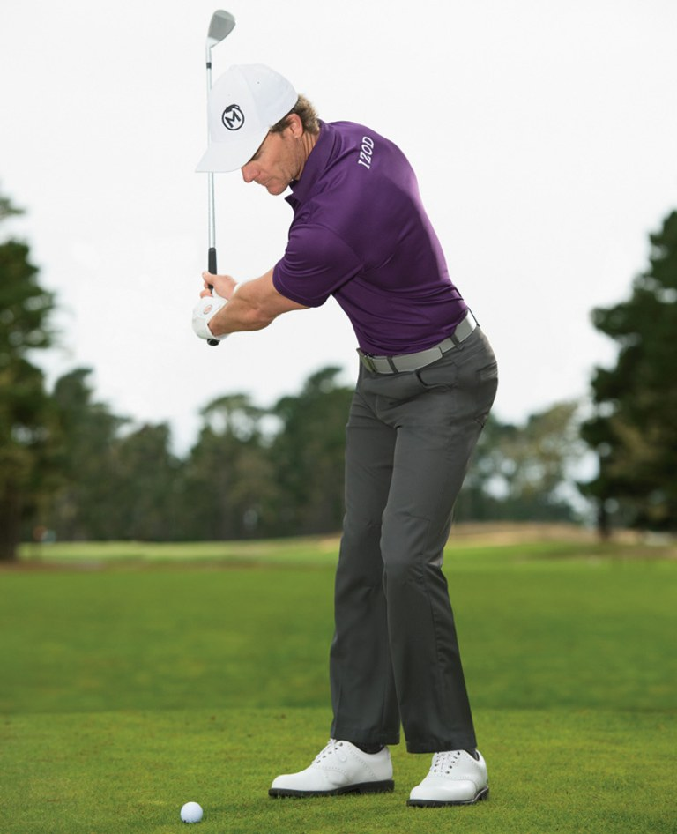

PUTTER - BUZZWORD: EVEN
Although the follow-through in a good putting stroke is twice as fast as the backstroke, most amateurs I see are all over the place with their putting speed. That's why my buzzword for putting is even. Thinking of creating an even-paced stroke back and through will help you make the proper accelerating movement into the ball and control the path. Download a metronome app for your phone. Set its beat interval to the pace of what feels like a good stroke. Then practice to that rhythm (below). Sometimes I think one, two on the backswing, and then boom, boom with the club striking the ball on the second boom. You'll find the metronome implants great rhythm in your stroke. You'll probably still hear the beat in your head when you play.

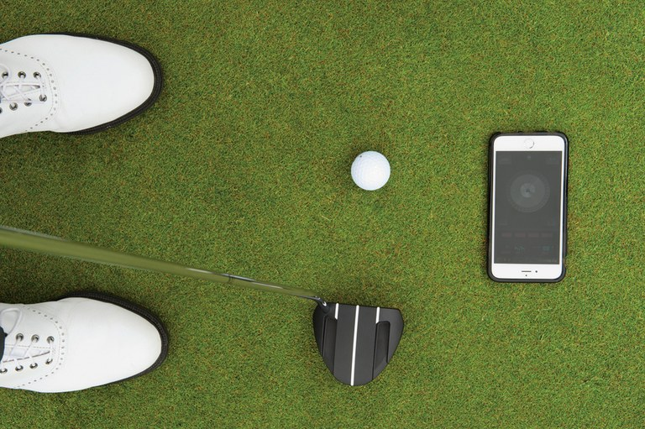

Swing Path, Swing Plane and Ball Flight
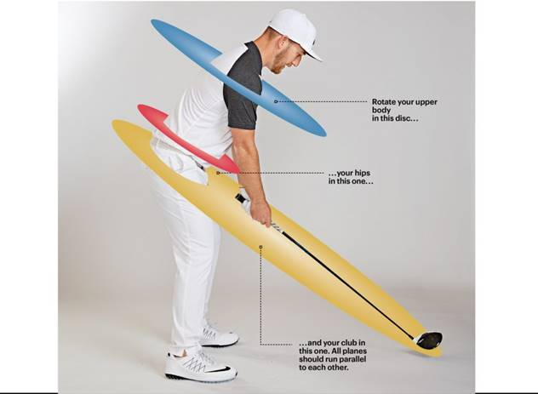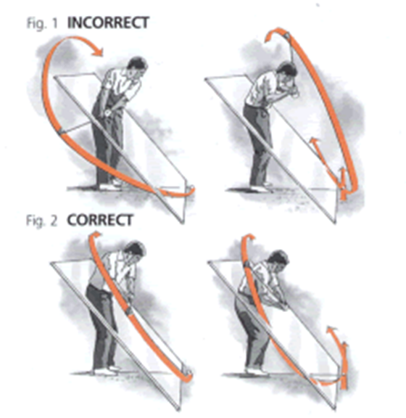

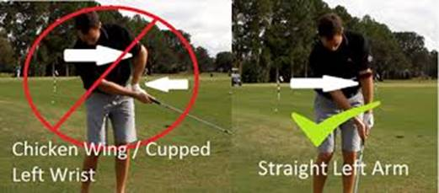

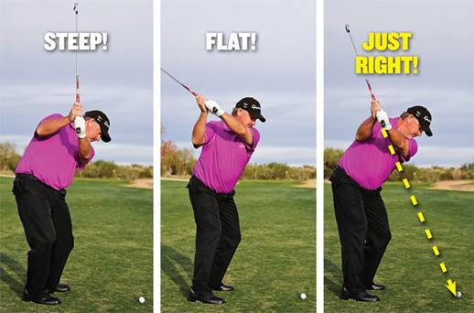

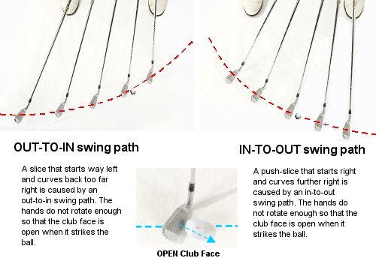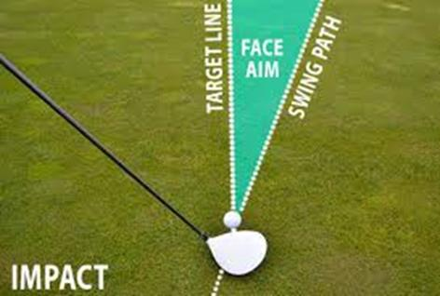

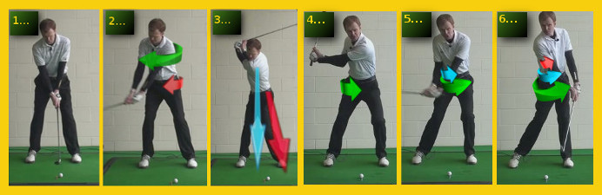

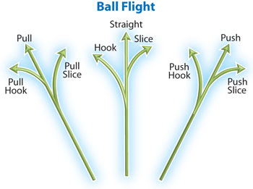

Pre-shot and Post-shot Routines

The pre-shot routine is a physical and mental sequence of actions to help golfers remain focused on the task at hand to play shots consistently well. Though the best golfers in the world might differ in the style of their swing, you will notice a similar sequence of actions for every shot. For instance, they will have a certain number of practice swings before setting up to the ball followed by a specific number of glances toward the target.
As well as a pre-shot routine, most golfers will also have a post-shot or post-mistake routine to allow them to recognize what went wrong with their swing or putt, and engage in a preferred action sequence. For example, after a poor swing, you will notice some golfers repeat their preferred swing. In match play, some golfers retake the missed putt before heading to the next tee.

Why are routines important? Routines are important for at least three reasons. First, they allow the golfer to remain consistent in the fundamentals of the set-up. The golfer can ensure that her grip, alignment, stance and posture are consistent each time she prepares for a shot. The best golfers in the world are always working on these fundamentals. Second, rather than thinking about irrelevant aspects of the game, such as the score or your opponent’s shot to the green, you can pay attention to what you need to do to play your shot well. Finally, routines that are well practiced help us to move from conscious attention to unconscious attention – to execute the shot at hand. In other words, once we have engaged in a physical and mental sequence that is well learned, we can allow the shot to unfold without consciously attending to the mechanics of the swing. We let the swing do its thing.
A useful way to develop a pre-shot routine is to consider the acronym PAR. This acronym can represent: Preparation, Action, and Revision.

In the Preparation section, you can assess the shot at hand. For example, you might examine the lie of your ball, the wind speed and direction, the pin placement and any particular hazards you need to avoid. Then you plan the shot that is best for you, considering your skills and ability at this time. The advice we offer here is be conservative but confident. In other words, choose conservatively but play confidently.
Once you have decided on the shot you intend to play, and the club you intend to use, you can swing the club or putter to feel the shot you wish to make while imagining the flight or path of the ball. Create a clear picture of what you want to happen. Now, you can step into the ball and ensure your grip, alignment, stance and posture is right for your shot.

In the Action stage, you will have set-up correctly to the ball and you are about to begin your swing sequence. Some golfers engage in an action to begin their swing such as a forward press of the club while other golfers sit back into their posture. Others just begin to take away their club when they feel ready. One useful sequence of actions we have found beneficial for allowing the swing to begin, without conscious control, has been the following: Target – Ball – Smooth Away. The golfer looks at the Target for the final time, then draws his eyes back to the Ball and Smoothly draws his club away from the ball. This sequence is beneficial for two reasons. First, the golfer can pay attention to the two things that matter most at this stage: his target and letting his swing do its thing. Second, it reduces the ‘thinking time’ for golfers who might begin to worry about unnecessary things to play their best golf.

The final stage, Revision, is a vital element of the pre-shot/post-shot routine because it allows the golfer to accept the outcome of the shot and move on to the next one. Most golfers will think and feel a particular way after they have hit their shots because they will have spent a lifetime watching the outcome of each shot they have ever hit. Good shots give us good feelings and we begin to think good things about ourselves. When other golfers see our good shots they usually say “well done, great shot,” which acknowledges your competence in golf. After a poor shot, however, they might remain silent or say something like: “don’t’ worry about that one, you can get up and down from there.” If we allow them, poor shots will prompt us to think and feel negatively about our golf game and ourselves. Golfers with a sound self-image know that one or a few poor shots are normal in golf and they can recover from them. They know that poor shots do not make them ‘bad golfers’ or ‘bad people’. They keep the entire game in perspective.

It is a sensible idea to learn to accept the outcome of each shot as an objective measure of where the ball travelled. What we mean here is not to attach any valuations about you to the outcome of the shot. This is a challenging but worthwhile thinking skill to learn. If the ball consistently travels further left than you would wish, you can ask your teaching professional to examine your swing when you leave the golf course.

