

Eagle Level
Golf Instruction Tips and Drills

Hold Cues:
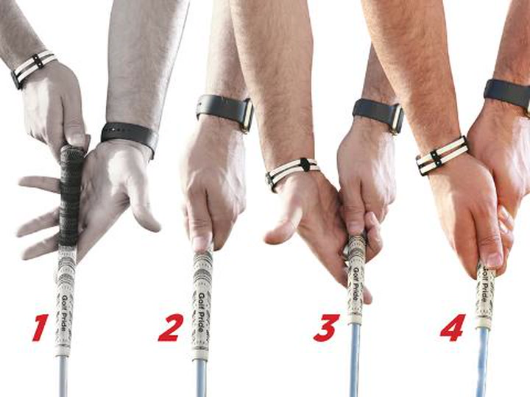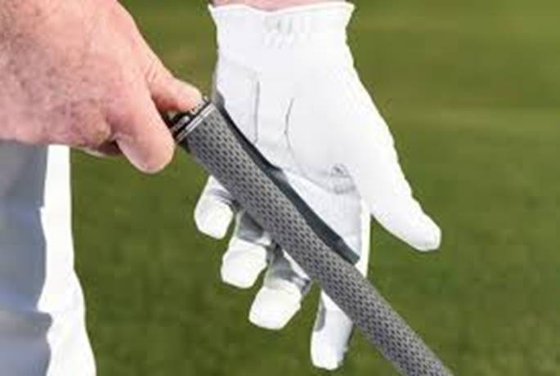
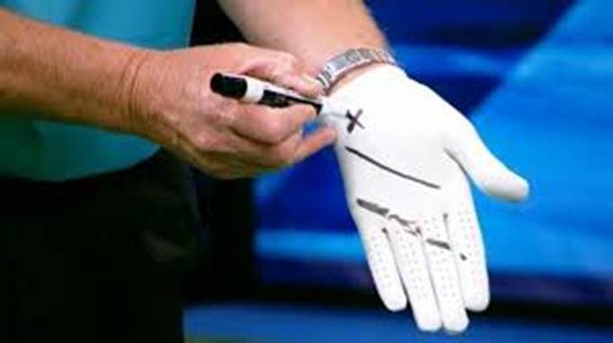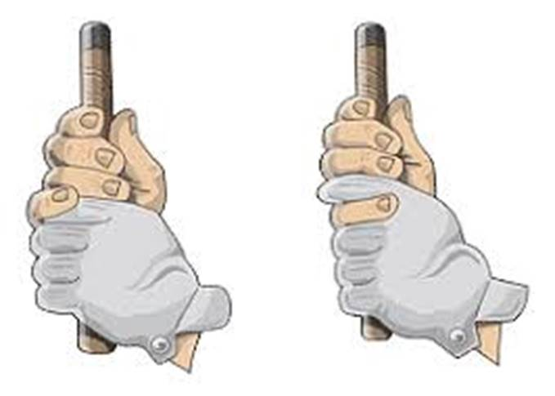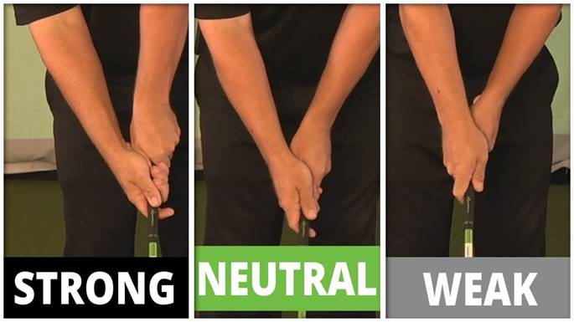
Set Up Cues:
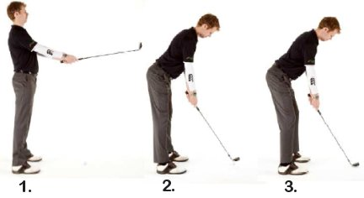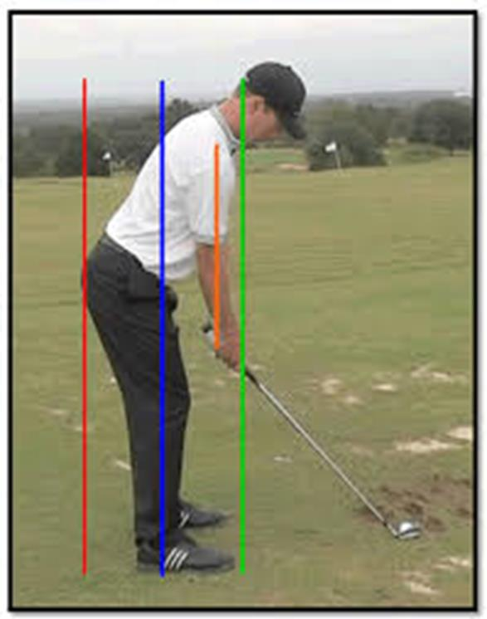
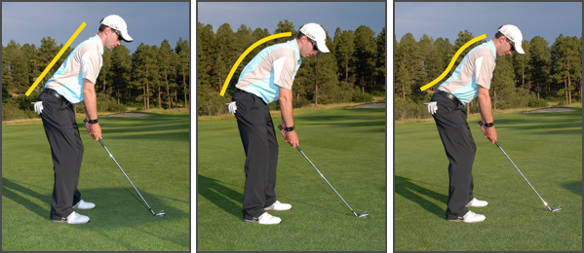
Yes No No
Alignment Cues:
Golf Swing Aim and Alignment
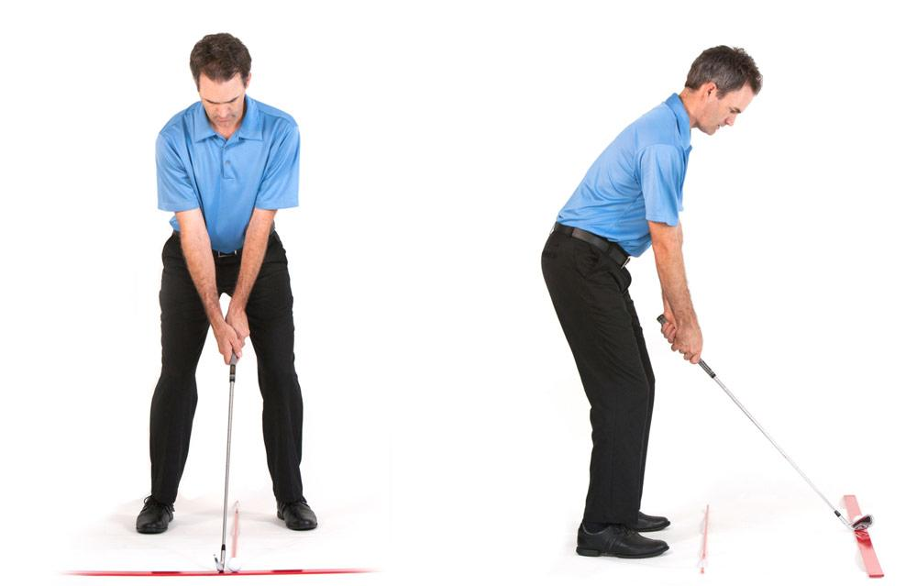
Alignment is the concept of addressing the golf ball with your body and club face directed precisely at the intended target. If consistent results are expected, then a consistent alignment is necessary. Otherwise, if a player’s alignment changes for every golf shot, every golf swing must change in order to produce consistent results.
Determine a Target and Target Line
Once all other variables have been considered (wind, slope, hazards, lie, etc.), you must decide on a distinct point where you intend the ball to finish. Let’s assume a straight ball flight is desired; working the ball will come later. The target cannot be a generalized area, but should be as precise as possible. Consider a straight line from the ball to the target to be the target line. This will be the focus around which all alignment takes place.
Soling the Clubhead
Begin with the clubhead. Clubface angle is one of only 2 major variables that determine the direction the golf ball will travel, so be precise. Be sure that the sole, or bottom of the clubhead rests completely flat on the ground. Neither the toe nor heel of the club should be raised higher than the other. In other words, the grooves on the clubface should be parallel to the ground. This will affect direction as well as consistency of contact.
Clubface Alignment
Be sure that the leading edge, bottom edge, and/or grooves of the clubface are set perpendicular to the target line. Depending on the club being used, a few degrees off with clubface alignment could mean many yards off line for the shot. When the club is set in the proper position, trust it, and leave it alone for the remainder of the setup.

Body Alignment
Assuming you are hitting a straight shot, your body will be facing exactly perpendicular to the target line. An easier way to regard this problem is to look at line drawn across a player’s feet, knees, hips, shoulders, and even eyes. Ideally, all of these connecting lines should align parallel to the target line. This is one of the most important, but underrated aspects of the entire golf swing. Tour professionals check this alignment on a daily basis. Before you begin, notice that your body is aligning parallel to the target line and not at the target itself. Many players make the mistake of directing both the clubface and their bodies at the target. This would mean that the two lines are not parallel, but converging. For right-handed players, the body is aligned distinctly to the left of the target.
Using Golf Clubs or Tour Sticks for Alignment (Practice Only)
To be sure that your alignment is correct, you will need a few extra golf clubs on the practice range. First, place one club on the ground, in front of the golf ball, directed straight at your target. It may help to stand behind the ball to be sure that you are accurate. This will highlight your target line. Toe Line / Body Line Next, place another club on the ground just in front of where your toes will be at address. This club must be set perfectly parallel to the target line club (shafts should be equidistant from each other at both ends). Take a moment to step back behind the ball and notice where the second club is pointing relative to your target. As mentioned above, this shaft (for right-handed players) should align well to the left of the target. These are parallel, not converging lines.
Checking Body Position
When you are set up to the ball, hold still. Have someone hold a shaft across your heels, knees, hips, shoulders, and eyes while ensuring that all lines are parallel to both clubs on the ground. If one of these lines is significantly off-line, you will need to re-orient yourself and set up over again. When all of your lines are parallel, you will be aligned target-ward. This will give you the greatest chance of making a golf swing that is on plane, accurate, and consistent.
You might also note that because your right hand is positioned slightly further down the club than your left hand, your right shoulder may in fact be situated slightly lower than your left shoulder. This tilt in our shoulders is certainly okay and is actually expected. Alignment problems arise however, if we allow our shoulders to open, so be conscious of this tendency. Alignment calls for regular attention and maintenance as it directly affects the path that the club head will travel on, as well as how consistent your shots will reach your target.
In summary, the target line is defined as a straight line from the ball to our intended target. Start by setting the club face down on the ground first, trust it, and then let it serve as a guide for the rest of your set up. All of your body lines including your feet, knees, hips, and shoulders should be parallel to your target line. Because your right hand sits on the club lower than your left, your right shoulder may be situated slightly lower than your left. This is perfectly fine, just don’t allow your shoulders to open or close as this will affect the path that your club is going to travel.
Target Awareness Cues:
Use alignment rods to help students properly aim at their target. Show them how a little change in their alignment makes a big difference down the fairway.

Pick a Target
The first part of the aiming process is simply picking a target for the shot at hand. Believe it or not, some golfers even neglect making target selection a part of their game.
Without a target in mind, you will have no way of knowing where to aim, and you will have very little chance of hitting a quality shot. Your target doesn’t always have to be the hole itself, either – you could be aiming away from the cup for safety, or you could be playing your tee shot into the wide side of the fairway for a good angle on the approach. It will be up to you to decide how aggressive or conservative you want to be with your targets. No matter what kind of target you pick, it is absolutely essential that you do pick one before moving on to the next step.

Find an Intermediate Target
This next step is where the average golfer falls out of line with the aiming process used by most professional golfers. Instead of walking up and hitting the shot after picking a target, most pros will pick an intermediate target that they can use to aim up the shot. This intermediate target is usually just a few feet in front of the ball, and it is located directly on the line between your ball and the selected target.
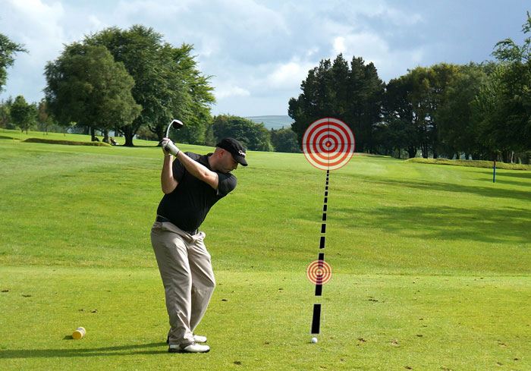
The idea is simple – instead of trying to aim at the target that may be hundreds of yards away, you can use the intermediate target that you have picked to aim your club properly. As long as you are aimed accurately with your intermediate target, you can feel great knowing that you are aiming correctly at the actual target as well. So what should you pick for an intermediate target? You will be surprised at how many options you have when you look carefully at the ground in front of your ball. There is bound to be a small discolored spot or a blade of grass that is longer than the rest. Take a look down your target line while standing behind the ball and pick out something that you can easily spot from address. Once you stand over the ball, align your club face with that short target, take your stance, and get ready to hit a great shot.

Body Balance - At the foundation of every good golf swing is good balance. Maintain your balance and you can deliver the club head to the ball with both speed and accuracy. Lose your balance and your swing loses its tempo, or rhythm, and falls apart.
To find the correct balance, it’s essential to know where your weight should be during the swing. Following are three balance checkpoints during the swing, as well as drills to help you feel the correct balance and more solid shots.

ADDRESS - At address, your weight should be balanced equally over the insteps of both feet — not toward the heels or the toes. This puts you in an athletic, ready position, like a tennis player awaiting serve. From this dynamic position, your body is ready to quickly move in any direction.
If your weight falls on your toes, the club head will tend to start outside the target line. If your weight rests on your heels, the path will tend to be too inside. Neither path is conducive to generating much clubhead speed or consistent contact.

To check your balance at address, simply jump straight up in the air. If you’re in balance, you should land comfortably on both feet without falling forward or backward.

TOP OF SWING - As your upper body coils, about 90 percent of your weight shifts over the right side. It’s imperative to maintain a good right knee flex. Many golfers lose their balance because of tension in their legs. They tighten their knees, which forces the right knee to straighten at the top of the backswing, leading to a reverse-pivot. At the top of the backswing, your balance point is over the middle of your right foot. If it is, you should be able to lift your left leg completely off the ground and hold the position to a count of three, without wavering.

FINISH - On the follow-through, the swing’s momentum should carry you to a full, balanced position, with almost all of your weight over your left foot. As your upper body unwinds, your shoulders should finish over your left leg, almost at a right angle to the leg. If your shoulders are leaning backwards at the finish, it’s very difficult to remain balanced. Your finish helps dictate your swing. Finish in balance and it’s a good bet your entire swing was in balance. If you’re stumbling at the finish, chances are your rhythm and timing are off, and the shot less than satisfying.

DANCE DRILL - To feel where your balance should be at the top of your swing and at the finish, try the following. From a position at the top of your backswing, lift your left foot off the ground, balancing your weight over your right leg. Then swing to the finish, lifting your right foot off the ground as your body rotates through the shot. Your weight should now be over your left leg. If you can do this drill without losing a step, you’re well on your way to a balanced swing.

NO PEEK DRILL - Find a safe spot on the driving range and take your normal swing, eyes open and focused on the target. Do not contact the ball. Then make the same swing blindfolded (or at least with your eyes closed). Finally, step up to the ball and try to hit it without looking. Believe it or not, I’ve seen some great shots with the eyes closed. Why? Because when you’re unable to see the flight of the ball, it’s much easier to sense any disturbance in balance. You’ll know right away if you’re swinging the club too fast to control. When your vision is taken away, you begin to sense balance internally. Try this drill several times, concentrating on maintaining balance. Once you become proficient hitting in the dark, try to maintain the same tempo with your eyes open.

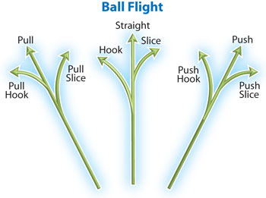 Pre-shot and Post-shot Routines
The pre-shot routine is a physical and mental sequence of actions to help golfers remain focused on the task at hand to play shots consistently well. Though the best golfers in the world might differ in the style of their swing, you will notice a similar sequence of actions for every shot. For instance, they will have a certain number of practice swings before setting up to the ball followed by a specific number of glances toward the target.

As well as a pre-shot routine, most golfers will also have a post-shot or post-mistake routine to allow them to recognize what went wrong with their swing or putt, and engage in a preferred action sequence. For example, after a poor swing, you will notice some golfers repeat their preferred swing. In match play, some golfers retake the missed putt before heading to the next tee.
Why are routines important? Routines are important for at least three reasons. First, they allow the golfer to remain consistent in the fundamentals of the set-up. The golfer can ensure that her grip, alignment, stance and posture are consistent each time she prepares for a shot. The best golfers in the world are always working on these fundamentals. Second, rather than thinking about irrelevant aspects of the game, such as the score or your opponent’s shot to the green, you can pay attention to what you need to do to play your shot well. Finally, routines that are well practiced help us to move from conscious attention to unconscious attention – to execute the shot at hand. In other words, once we have engaged in a physical and mental sequence that is well learned, we can allow the shot to unfold without consciously attending to the mechanics of the swing. We let the swing do its thing.

A useful way to develop a pre-shot routine is to consider the acronym PAR. This acronym can represent: Preparation, Action, and Revision.

In the Preparation section, you can assess the shot at hand. For example, you might examine the lie of your ball, the wind speed and direction, the pin placement and any particular hazards you need to avoid. Then you plan the shot that is best for you, considering your skills and ability at this time. The advice we offer here is be conservative but confident. In other words, choose conservatively but play confidently.
Once you have decided on the shot you intend to play, and the club you intend to use, you can swing the club or putter to feel the shot you wish to make while imagining the flight or path of the ball. Create a clear picture of what you want to happen. Now, you can step into the ball and ensure your grip, alignment, stance and posture is right for your shot.

In the Action stage, you will have set-up correctly to the ball and you are about to begin your swing sequence. Some golfers engage in an action to begin their swing such as a forward press of the club while other golfers sit back into their posture. Others just begin to take away their club when they feel ready. One useful sequence of actions we have found beneficial for allowing the swing to begin, without conscious control, has been the following: Target – Ball – Smooth Away. The golfer looks at the Target for the final time, then draws his eyes back to the Ball and Smoothly draws his club away from the ball. This sequence is beneficial for two reasons. First, the golfer can pay attention to the two things that matter most at this stage: his target and letting his swing do its thing. Second, it reduces the ‘thinking time’ for golfers who might begin to worry about unnecessary things to play their best golf.
The final stage, Revision, is a vital element of the pre-shot/post-shot routine because it allows the golfer to accept the outcome of the shot and move on to the next one. Most golfers will think and feel a particular way after they have hit their shots because they will have spent a lifetime watching the outcome of each shot they have ever hit. Good shots give us good feelings and we begin to think good things about ourselves. When other golfers see our good shots they usually say “well done, great shot,” which acknowledges your competence in golf. After a poor shot, however, they might remain silent or say something like: “don’t’ worry about that one, you can get up and down from there.” If we allow them, poor shots will prompt us to think and feel negatively about our golf game and ourselves. Golfers with a sound self-image know that one or a few poor shots are normal in golf and they can recover from them. They know that poor shots do not make them ‘bad golfers’ or ‘bad people’. They keep the entire game in perspective.
It is a sensible idea to learn to accept the outcome of each shot as an objective measure of where the ball travelled. What we mean here is not to attach any valuations about you to the outcome of the shot. This is a challenging but worthwhile thinking skill to learn. If the ball consistently travels further left than you would wish, you can ask your teaching professional to examine your swing when you leave the golf course.

