

PLAYer Level
Golf Instruction Tips and Drills

Grip Basics

Before splitting into groups for the activities go over the basic grip fundamentals. Work individually with each child to get a good starting grip. See diagrams below.

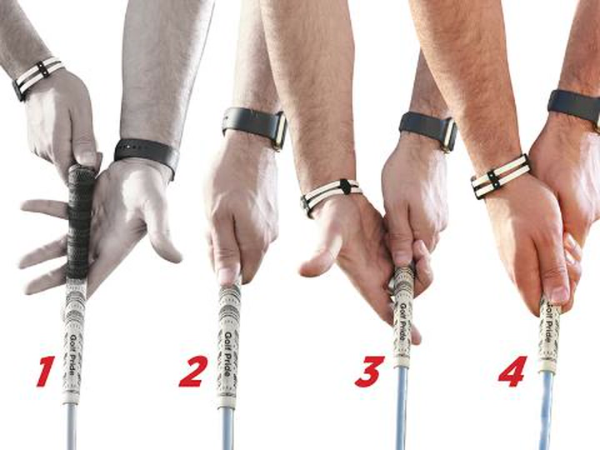

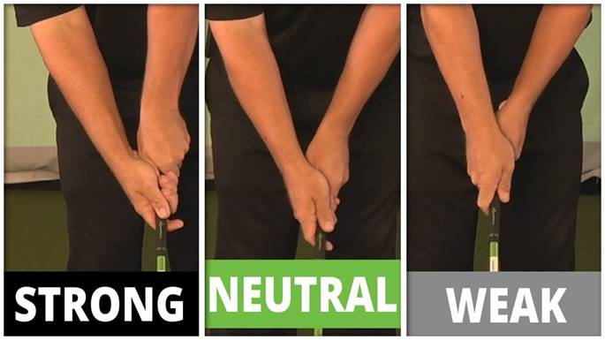
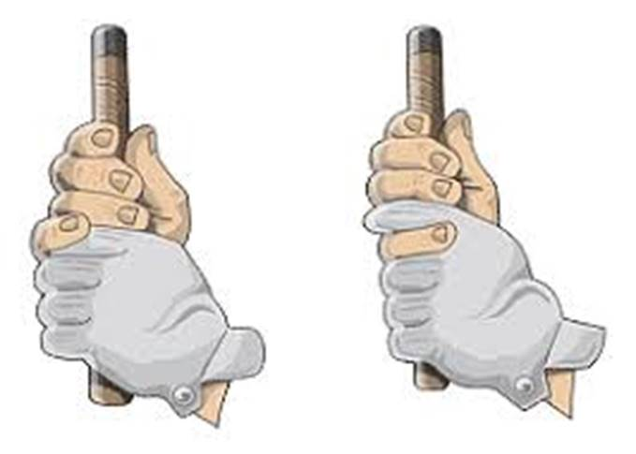

Stance and Posture Basics

Before splitting into groups for the activities go over the basic stance and posture fundamentals. Work individually with each child to get a good starting stance and posture.

When teaching a proper golf stance, always start with a simple question: “What other sports have you played before?” This is important because often times players can relate certain elements from other sports to help them better understand golf. Golf is an athletic sport and therefore we need to setup in an athletic position.

See diagrams below.

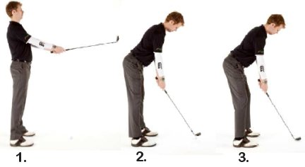

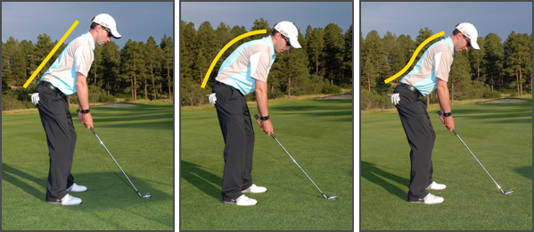
Yes No No
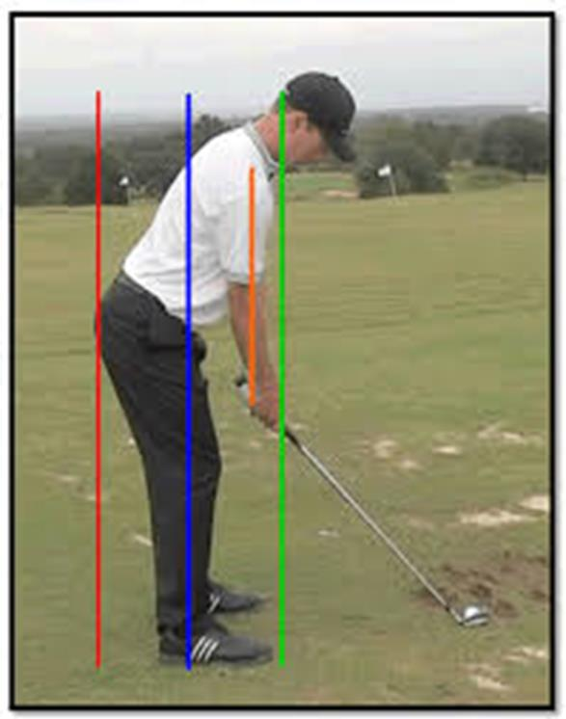
Pick a Target
The first part of the aiming process is simply picking a target for the shot at hand.
Without a target in mind, the player will have no way of knowing where to aim, and will have very little chance of hitting a quality shot. The target doesn’t always have to be the hole itself, either.
No matter what kind of target they pick, it is absolutely essential that they do pick one before moving on to the next step.
Find an Intermediate Target
Find an intermediate target. This intermediate target is usually just a few feet in front of the ball, and it is located directly on the line between the ball and the selected target.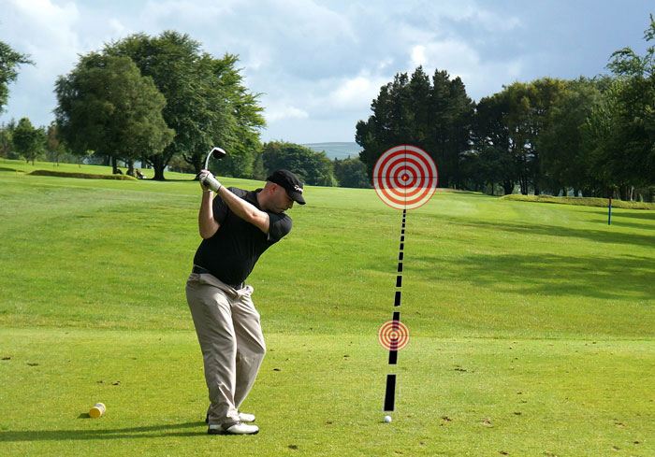

The idea is simple – instead of trying to aim at the target that may be hundreds of yards away, they can use the intermediate target that they have picked to aim their club properly. As long as they are aimed accurately with their intermediate target, they can feel great knowing that they are aiming correctly at the actual target as well.
So what should they pick for an intermediate target? They will be surprised at how many options they have when they look carefully at the ground in front of their ball. There is bound to be a small discolored spot or a blade of grass that is longer than the rest. Have them take a look down the target line while standing behind the ball and pick out something that they can easily spot from address. Once they stand over the ball, align their club face with that short target, take their stance, and get ready to hit a great shot.
- Target Selection- Picking out the target by looking down the target line-standing behind the golf ball and visualizing your shot, both ball and target.
- Distance to the Target- for beginning players this could be a simple as asking “do I use my far, medium or short distance club?” Intermediate players can identify the distance and make a club selection.
- Reaction to the Target- we want to encourage players to get ready (pick out a target), get set (set up to the ball), and go (swing wasting little time looking at the ball).

Think about this - If players pointed a camera at the ground (or the ball), the camera would take a different picture than if the players pointed a camera towards the target in the fairway. Some swing technique issues can be addressed by changing the lens through which the target is viewed.

Alignment is the concept of addressing the golf ball with your body and club face directed precisely at the intended target. If consistent results are expected, then a consistent alignment is necessary.

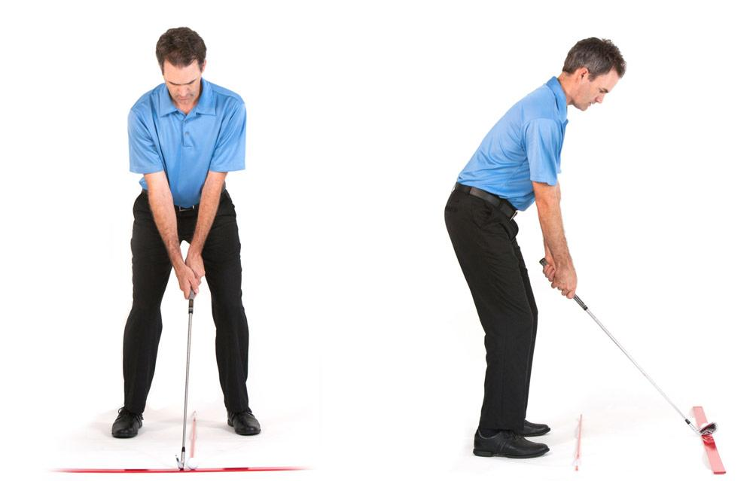
Soling the Club head - Begin with the club head. Clubface angle is one of only 2 major variables that determine the direction the golf ball will travel, so be precise. Be sure that the sole, or bottom of the clubhead rests completely flat on the ground. Neither the toe nor heel of the club should be raised higher than the other. In other words, the grooves on the clubface should be parallel to the ground. This will affect direction as well as consistency of contact.
Clubface Alignment - Be sure that the leading edge, bottom edge, and/or grooves of the clubface are set perpendicular to the target line. Depending on the club being used, a few degrees off with clubface alignment could mean many yards off line for the shot. When the club is set in the proper position, trust it, and leave it alone for the remainder of the setup.
Body Alignment - Assuming you are hitting a straight shot, your body will be facing exactly perpendicular to the target line. An easier way to regard this problem is to look at line drawn across a player’s feet, knees, hips, shoulders, and even eyes. Ideally, all of these connecting lines should align parallel to the target line. This is one of the most important, but underrated aspects of the entire golf swing. Tour professionals check this alignment on a daily basis. Before you begin, notice that your body is aligning parallel to the target line and not at the target itself. Many players make the mistake of directing both the clubface and their bodies at the target. This would mean that the two lines are not parallel, but converging. For right-handed players, the body is aligned distinctly to the left of the target.
Using Golf Clubs or tour sticks for Alignment (Practice Only)
To be sure that your alignment is correct, you will need a few extra golf clubs on the practice range. First, place one club on the ground, in front of the golf ball, directed straight at your target. It may help to stand behind the ball to be sure that you are accurate. This will highlight your target line.T oe Line / Body Line Next, place another club on the ground just in front of where your toes will be at address. This club must be set perfectly parallel to the target line club (shafts should be equidistant from each other at both ends). Take a moment to step back behind the ball and notice where the second club is pointing relative to your target. As mentioned above, this shaft (for right-handed players) should align well to the left of the target. These are parallel, not converging lines.

Ball Position – Review ball position / clubs with the participants in a group. See diagrams below.
